**Self-review: Sorting data**

In the exercise *Sorting data*, you sorted data in a worksheet. You first downloaded the file *Adventure Works Inventory.xlsx* and customized the relevant worksheet. You then performed a series of alpha-numeric sorts within the worksheet.

Your final worksheet should resemble the screenshot:

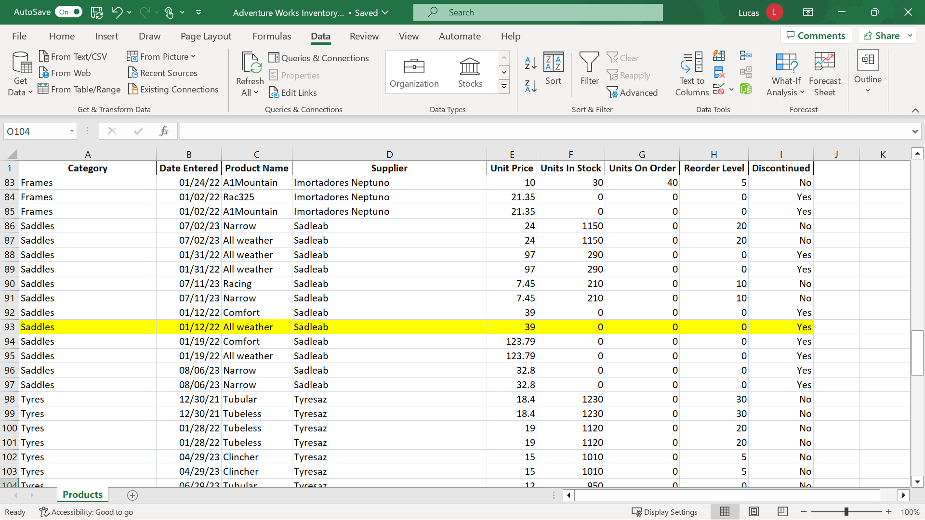

Now it’s time to review your understanding of the tasks you completed by answering the questions that follow. Don’t forget that you can revisit the previous learning items to recap the process steps.

**1.**

Question 1

In the exercise, you sorted the **Products** worksheet data by the **Product Name** information stored in **column C**. Which of the following steps did you perform first, so that data would be sorted when you selected the **Sort Ascending** choice?

Select column **C** by selecting the column initial.

Select any cell in column **C**.

Select **Product Name** from a drop-down list.

Status: [object Object]

1 point

**2.**

Question 2

You were asked to sort the data first by **Supplier** and then by **Units in Stock**. Which choice did you select on the **Data** ribbon to perform this?

Sort

Sort Z to A

Sort A to Z

Status: [object Object]

1 point

**3.**

Question 3

True or False: You used **Sort** to sort the data using two columns with a first-level sort by **Supplier** and a second-level sort data by **Units in stock**. This meant that when the sort was complete, the **Supplier** entries were no longer in alphabetical order.

True

False

Status: [object Object]

1 point

Coursera Honor Code  [Learn more](https://learner.coursera.help/hc/articles/209818863)

I, **STEVEN DANIEL**, understand that submitting work that isn’t my own may result in permanent failure of this course or deactivation of my Coursera account.*

You must select the checkbox in order to submit the assignment